SF.SmokeTestScripts_TC_SF_OBRequiredFieldsOnSalesStage_Instance1_12-Apr-2017_09-47-36_PM_Invoke_Application.png



SF.SmokeTestScripts_TC_SF_OBRequiredFieldsOnSalesStage_Instance1_12-Apr-2017_09-47-51_PM_Login.png

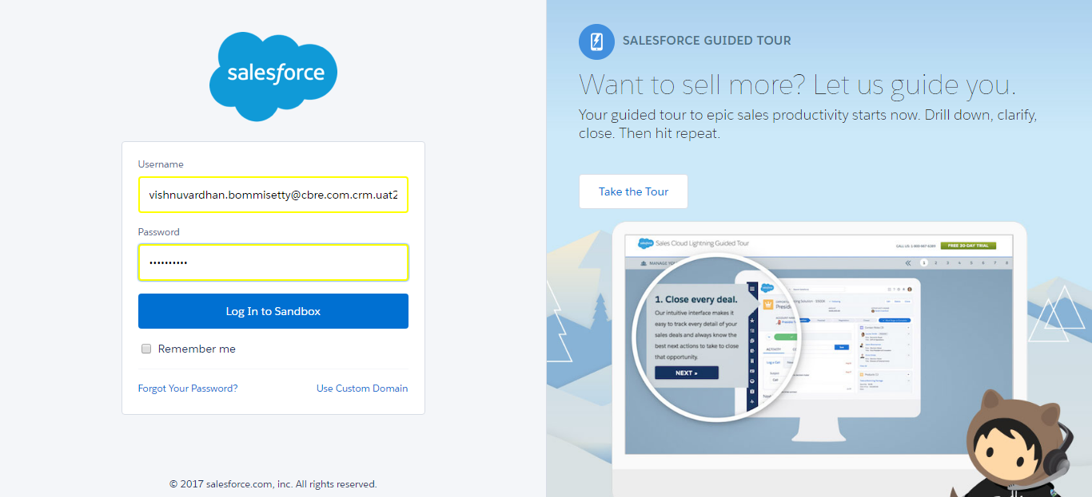

SF.SmokeTestScripts_TC_SF_OBRequiredFieldsOnSalesStage_Instance1_12-Apr-2017_09-48-04_PM_Verify_Login.png

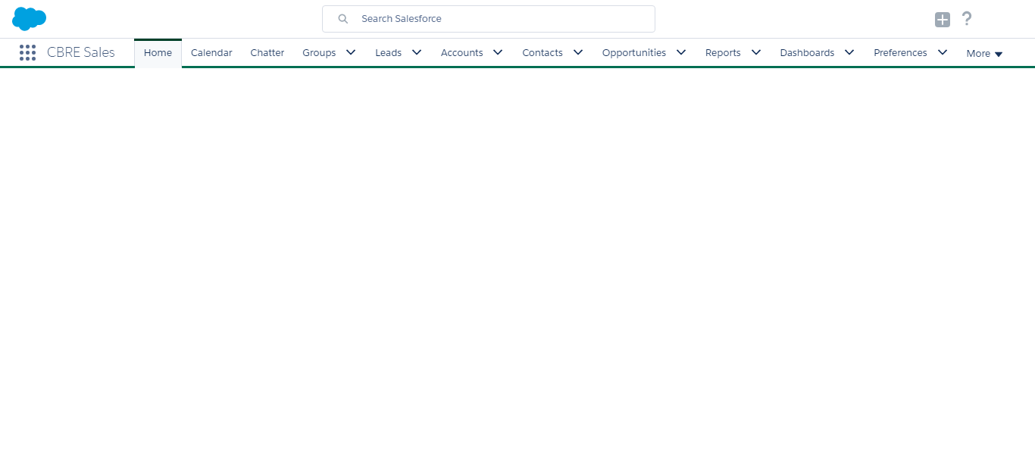

SF.SmokeTestScripts_TC_SF_OBRequiredFieldsOnSalesStage_Instance1_12-Apr-2017_09-48-06_PM_Verify_Fetch_Record.png

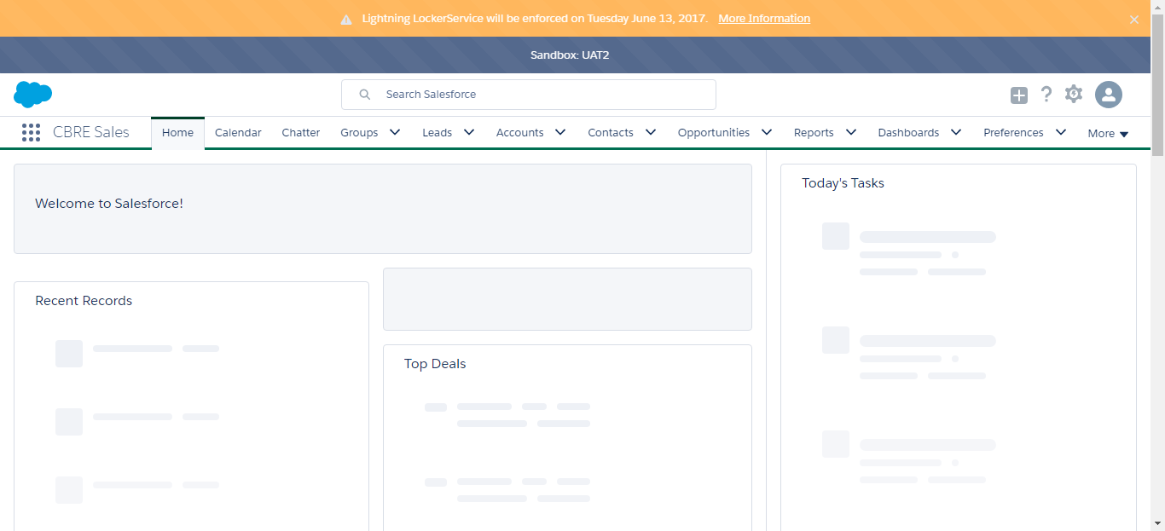

SF.SmokeTestScripts_TC_SF_OBRequiredFieldsOnSalesStage_Instance1_12-Apr-2017_09-48-06_PM_Verify_Opportunity_Required



SF.SmokeTestScripts_TC_SF_OBRequiredFieldsOnSalesStage_Instance1_12-Apr-2017_09-48-07_PM_Verify_Add_Opportunity_Page



SF.SmokeTestScripts_TC_SF_OBRequiredFieldsOnSalesStage_Instance1_12-Apr-2017_09-48-27_PM_Verify_Add_Opportunity_Page

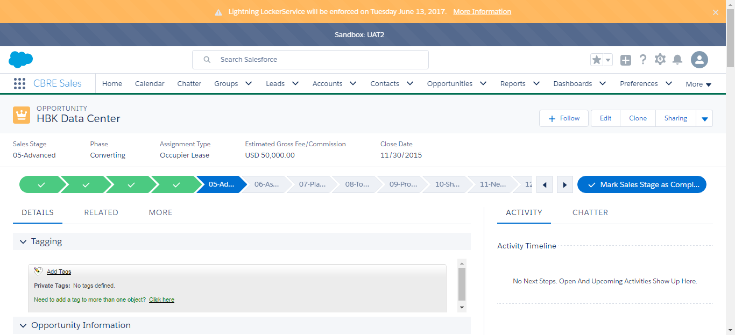

SF.SmokeTestScripts_TC_SF_OBRequiredFieldsOnSalesStage_Instance1_12-Apr-2017_09-48-40_PM_Error.png

